**Appendix-I**

**Photographs**

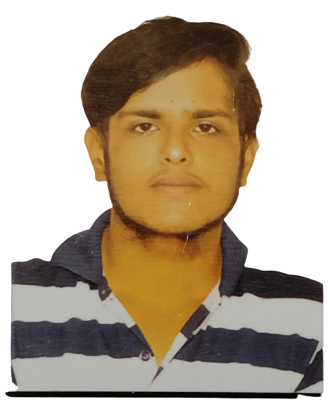

Kaushik Wagh R

19BTRIS047

Holachi Vaishnavi

19BTRIS059



Aman Kalavadia

19BTRIS019

Sagar Katekhaye

19BTRIS034



Ayush Kumar

19BTRIS048

**Group Photo**

**Appendix - II**

**Source Code**

# Arduino Code

#include <Servo.h>    //Servo motor library. This is standard library

#include <NewPing.h>  //Urltrasonic sensor function library. You must install this library

//our L298N control pins

const int LeftMotorForward = 8;

const int LeftMotorBackward = 9;

const int RightMotorForward = 10;

const int RightMotorBackward = 11;

//sensor pins

#define trig_pin A1  //analog input 1

#define echo_pin A0  //analog input 2

#define maximum_distance 200

boolean goesForward = false;

int distance = 100;

NewPing sonar(trig_pin, echo_pin, maximum_distance);  //sensor function

Servo servo_motor;                                    //our servo name

void setup() {

  pinMode(RightMotorForward, OUTPUT);

  pinMode(LeftMotorForward, OUTPUT);

  pinMode(LeftMotorBackward, OUTPUT);

  pinMode(RightMotorBackward, OUTPUT);

  servo_motor.attach(7);  //our servo pin

  servo_motor.write(115);

  delay(2000);

  distance = readPing();

  delay(100);

  distance = readPing();

  delay(100);

  distance = readPing();

  delay(100);

  distance = readPing();

  delay(100);

}

void loop() {

  int distanceRight = 0;

  int distanceLeft = 0;

  delay(50);

  if (distance <= 20) {

    moveStop();

    delay(300);

    moveBackward();

    delay(400);

    moveStop();

    delay(300);

    distanceRight = lookRight();

    delay(300);

    distanceLeft = lookLeft();

    delay(300);

    if (distance >= distanceLeft) {

      turnRight();

      moveStop();

    } else {

      turnLeft();

      moveStop();

    }

  } else {

    moveForward();

  }

  distance = readPing();

}

int lookRight() {

  servo_motor.write(50);

  delay(500);

  int distance = readPing();

  delay(100);

  servo_motor.write(115);

  return distance;

}

int lookLeft() {

  servo_motor.write(170);

  delay(500);

  int distance = readPing();

  delay(100);

  servo_motor.write(115);

  return distance;

  delay(100);

}

int readPing() {

  delay(70);

  int cm = sonar.ping_cm();

  if (cm == 0) {

    cm = 250;

  }

  return cm;

}

void moveStop() {

  digitalWrite(RightMotorForward, LOW);

  digitalWrite(LeftMotorForward, LOW);

  digitalWrite(RightMotorBackward, LOW);

  digitalWrite(LeftMotorBackward, LOW);

}

void moveForward() {

  if (!goesForward) {

    goesForward = true;

    digitalWrite(LeftMotorForward, HIGH);

    digitalWrite(RightMotorForward, HIGH);

    digitalWrite(LeftMotorBackward, LOW);

    digitalWrite(RightMotorBackward, LOW);

  }

}

void moveBackward() {

  goesForward = false;

  digitalWrite(LeftMotorBackward, HIGH);

  digitalWrite(RightMotorBackward, HIGH);

  digitalWrite(LeftMotorForward, LOW);

  digitalWrite(RightMotorForward, LOW);

}

void turnRight() {

  digitalWrite(LeftMotorForward, HIGH);

  digitalWrite(RightMotorBackward, HIGH);

  digitalWrite(LeftMotorBackward, LOW);

  digitalWrite(RightMotorForward, LOW);

  delay(500);

  digitalWrite(LeftMotorForward, HIGH);

  digitalWrite(RightMotorForward, HIGH);

  digitalWrite(LeftMotorBackward, LOW);

  digitalWrite(RightMotorBackward, LOW);

}

void turnLeft() {

  digitalWrite(LeftMotorBackward, HIGH);

  digitalWrite(RightMotorForward, HIGH);

  digitalWrite(LeftMotorForward, LOW);

  digitalWrite(RightMotorBackward, LOW);

  delay(500);

  digitalWrite(LeftMotorForward, HIGH);

  digitalWrite(RightMotorForward, HIGH);

  digitalWrite(LeftMotorBackward, LOW);

  digitalWrite(RightMotorBackward, LOW);

}

**Appendix-III**

**Datasheets**